SDMR Systems
Sensor Fusion Guide
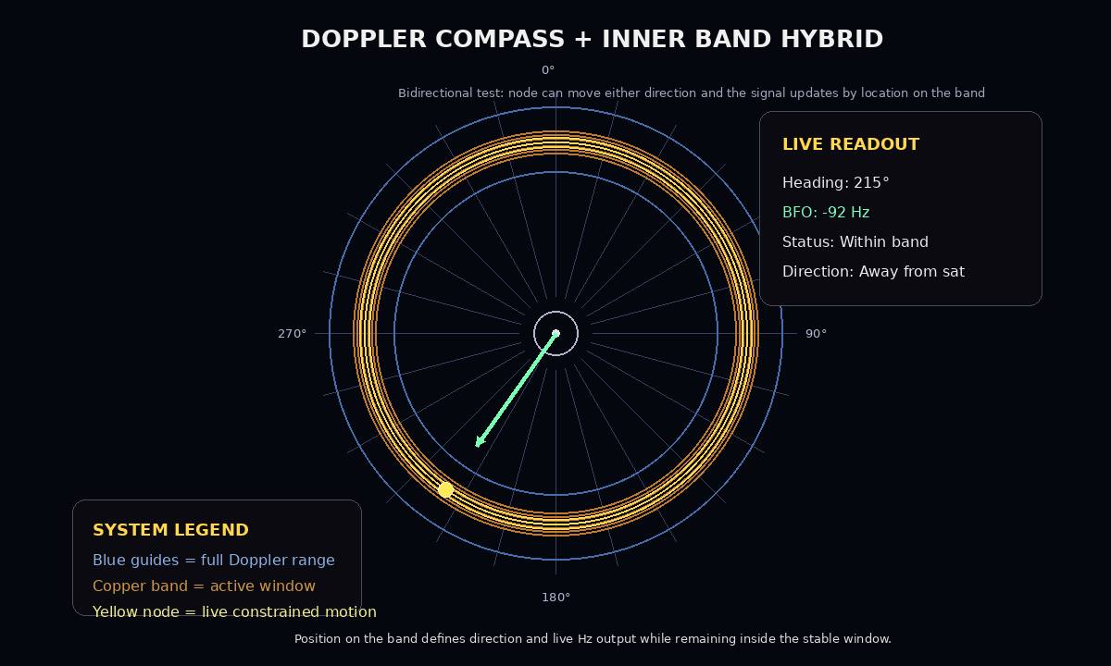

One Source Can Suggest. Multiple Sources Can Confirm.
Modern investigations rely on many independent sources of information. Radar, satellite communications, aircraft systems, weather, navigation procedures, maintenance records, and technical manuals each describe only part of the overall picture. Sensor Fusion brings these sources together into one synchronized investigation framework.

Why Sensor Fusion Matters
The challenge is not collecting information—it is connecting it. SDMR aligns independent sources on a common timeline so investigators can compare evidence, identify conflicts, and build a more complete understanding of events.

Information Sources
Source | Contribution
Radar | Aircraft position observations
Satellite | Communications and timing
ADS-B | Position broadcasts
ACARS | Operational messages
ATC Communications | Controller and crew interactions
Flight Manuals | Aircraft systems and procedures
Weather | Environmental conditions
Maintenance Records | Aircraft configuration history
Navigation Procedures | Published SID, STAR, and airway guidance
Performance Data | Aircraft capability and expected behavior

SDMR Sensor Fusion Workflow
Collect
↓
Synchronize
↓
Cross-Reference
↓
Validate
↓
Build Unified Timeline
↓
Support Flight Reconstruction

Benefits
- Complete picture across multiple independent sources
- Higher confidence through cross-validation
- Timeline accuracy through synchronization
- Conflict detection between sources
- Searchable, connected evidence framework

Conclusion
Sensor Fusion does not replace the investigator. It provides a connected view of the evidence so relationships between signals, procedures, manuals, and operational data can be examined together in a structured and transparent way.

